**PF**

**PROGRAMMING PROJECT**

**DUE DATE:** Thursday , December 23, 2021. (anytime till the labs are open)

**IMPORTANT**

* Your code should be properly commented
* Variable and function names should be meaningful and without abbreviations
* Your program should be user friendly
* Deduction of marks for messy and confusing code
* **Plagiarism will not be tolerated**. It will result in a straight F in the course and forwarded to DC committee, who might award 5 F’s in all courses you are taking.

You have to submit a complete working system, along with the source code and a readme file that tells us how to use your software.

**Bonus will be marked only if the core functionalities are complete.**

The weightage is 10%. If the students implement a text based game (rather than graphical), then the maximum marks that they can get is 6.

**DETAILS OF THE GAMES**

Bejeweled Blitz

Play this game at: <https://apps.facebook.com/bejeweledblitz/>

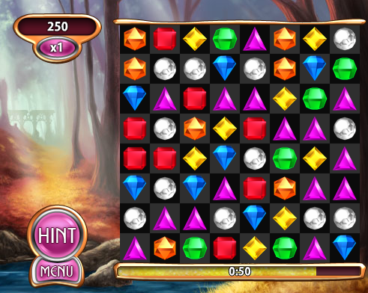



The tutorial is given below:

